**PROGRAMMING FUNDAMENTAL LAB 3**

TASK 1:

|  |
| --- |
| #include<stdio.h>  int main()  {int age;  printf("Enter a age:");  scanf("%d",&age);  if(age>=18)  {printf("You are eligible to vote");}  else  {printf("You are not eligible to vote");  }  return 0;} |

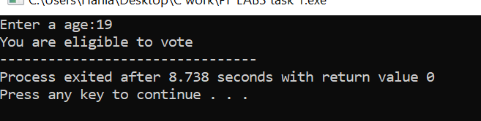

TASK 2:

|  |
| --- |
| #include<stdio.h>  int main()  {int num;  printf("Enter a number:");  scanf("%d",&num);  if(num%2==0)  {printf("Even number");}  else  {printf("Odd number");}  return 0;  } |

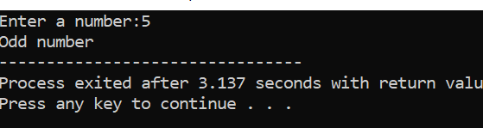

TASK 3:

|  |
| --- |
| #include<stdio.h>  int main()  {int num1,num2,num3;  printf("Enter three number:\n");  scanf("%d %d %d",&num1,&num2,&num3);  if(num1>num2 && num1>num3)  {printf("The largest number is %d",num1);  }  else if(num2>num1 && num2>num3)  {printf("The largest number is %d",num2);  }  else  {printf("The largest number is %d",num3);  }  return 0;} |

